# **CTF Challenge: Python Programming - Calculate the different formulas using GeeksforGeeks**



# **1. Introduction**

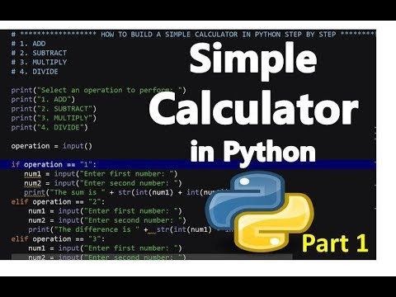

This challenge involves writing a Python script to calculate the area of a rectangle based on user input for its length and width. It tests your ability to handle user input, perform calculations, and format output in Python.

# **2. Tools and Requirements**

[**https://www.geeksforgeeks.org/**](https://www.geeksforgeeks.org/)

# **3. Scenario**



You are developing a Python program for a geometry class that needs to compute and display the area of rectangles. The program should prompt the user to enter the length and width of the rectangle, calculate its area, and then display the result.

# **4. Process to follow while performing CTF**

Step 1: Go to [**https://www.geeksforgeeks.org/**](https://www.geeksforgeeks.org/)and create your account

Step 2: Go to tutorials and select on Python

Step 3: Run the command there.

# **5. Let’s Begin the Challenge**

**Question**

**Flag 1:** **Print Numbers from 1 to 10 use this code: print(*range(1,11))**

*Answer: 1 2 3 4 5 6 7 8 9 10*

**Flag 2: Write formula to Calculate Simple Interest**

*Answer: simple_interest= (Principal * rate * time) / 100*

**Hint**



